**Task**:   
- write a console application;

**Input of application (via keyboard)**:  
- coordinates of 3 points in 2-dimensional coordinate system;

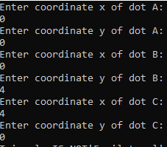

**Output of application (to console)**:  
- the length of triangle sides;  
- is it equilateral triangle?  
- is it isosceles triangle?  
- is it right triangle?  
- the perimeter of the triangle;  
- even numbers from 0 to value of triangle perimeter.

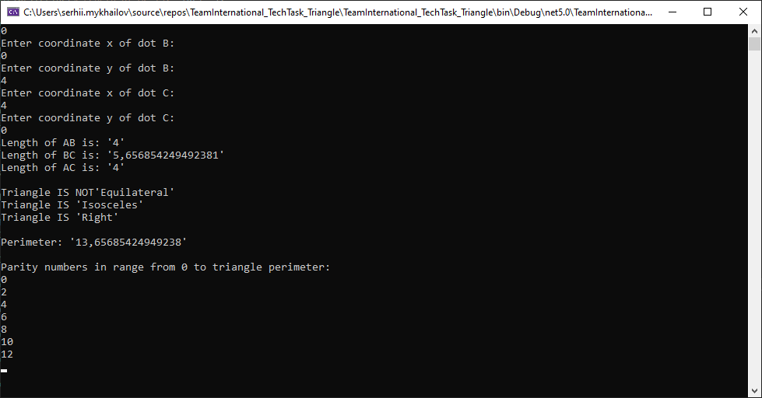

The source code of the application should be uploaded to a public github repository (see instruction in separated file).

**Note**:  
- input values can be with fractional part;  
- output values can be rounded;  
- you can choose you own precision during calculations:

For example, for a triangle *А(0,0), В(0,4), С(0,4)* sides length will be *4, 5,656854249492381, 4*. It is the right triangle, because АВ2 + АС2 = ВС2. But *42 + 42 != 5,6568542494923812* (due to a precision of double variable type).To solve this problem*,* you can say that the triangle is right if *ВС2 – (АВ2 + АС2) <= delta*, where *delta* – you own precision.

**Useful links**:

<https://docs.microsoft.com/en-us/visualstudio/get-started/csharp/tutorial-console?view=vs-2022> - simple C# console app;  
<https://docs.microsoft.com/en-gb/dotnet/csharp/language-reference/statements/selection-statements> - the if statement  
<https://docs.microsoft.com/en-gb/dotnet/csharp/language-reference/statements/iteration-statements> - the for statement;  
<https://docs.microsoft.com/en-us/dotnet/api/system.double.parse?view=net-6.0>

<https://docs.microsoft.com/en-us/dotnet/api/system.double.tryparse?view=net-6.0> – converting string to double;  
<https://docs.microsoft.com/en-us/dotnet/api/system.math.pow?view=net-6.0> - raise a specified number to the specified power

<https://docs.microsoft.com/en-us/dotnet/api/system.math.sqrt?view=net-6.0> - calculate square root of a specified number.